SURVEYING PRECISION

INDUSTRIAL SURVEYING

COMPANY’ S PROJECTS

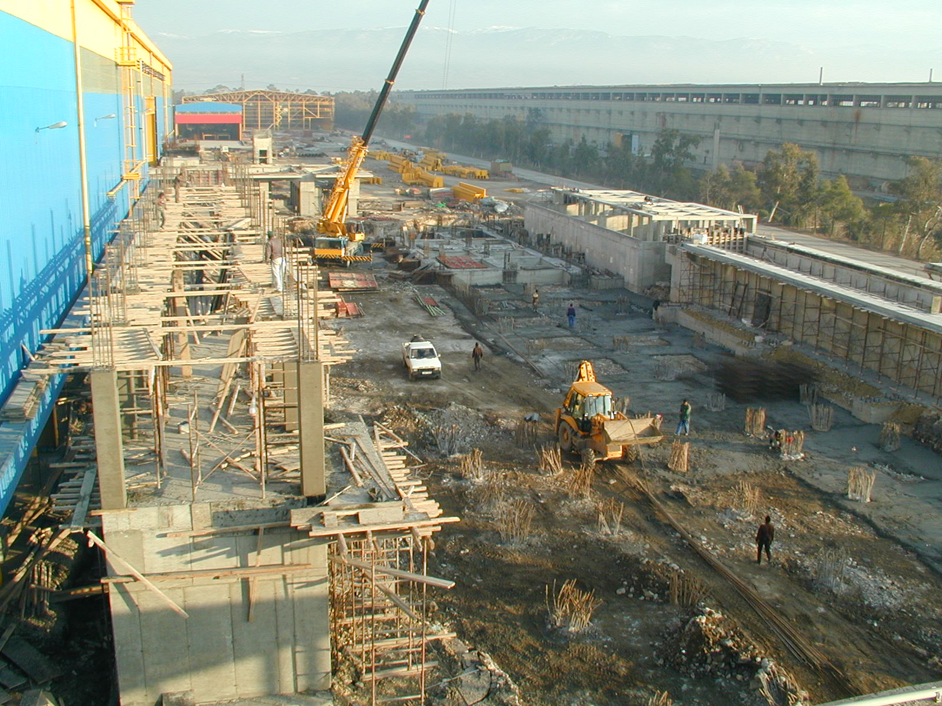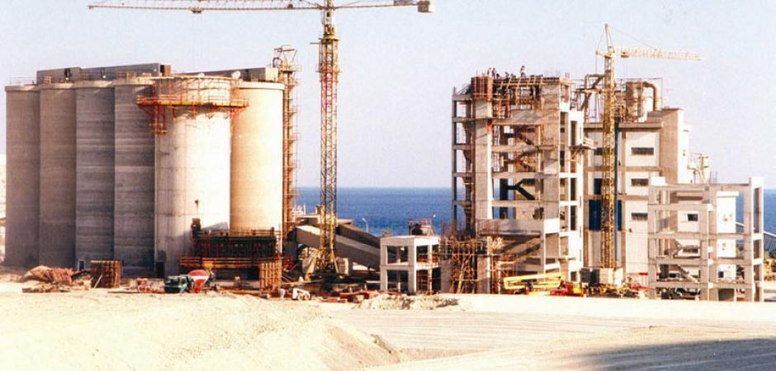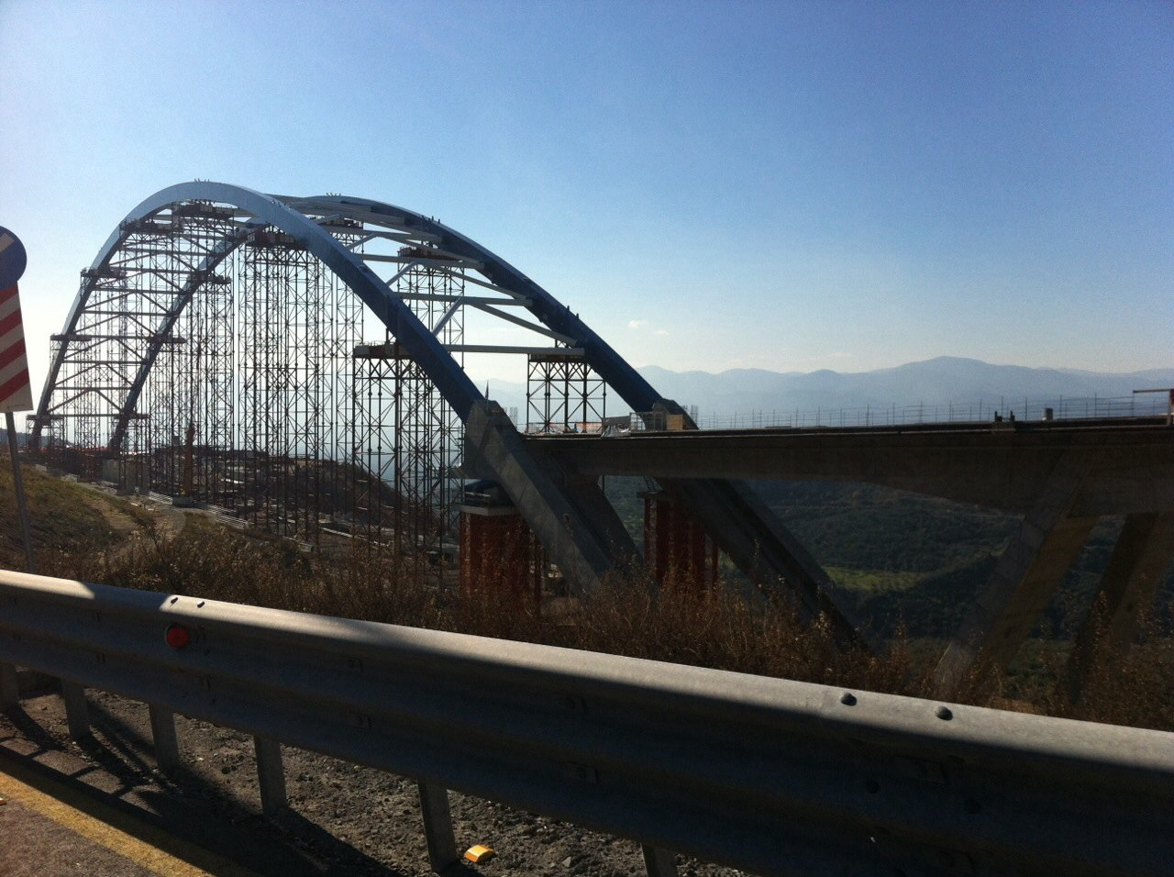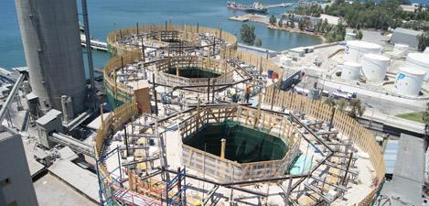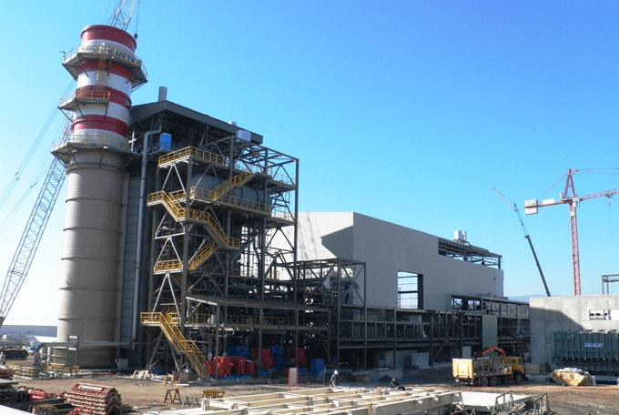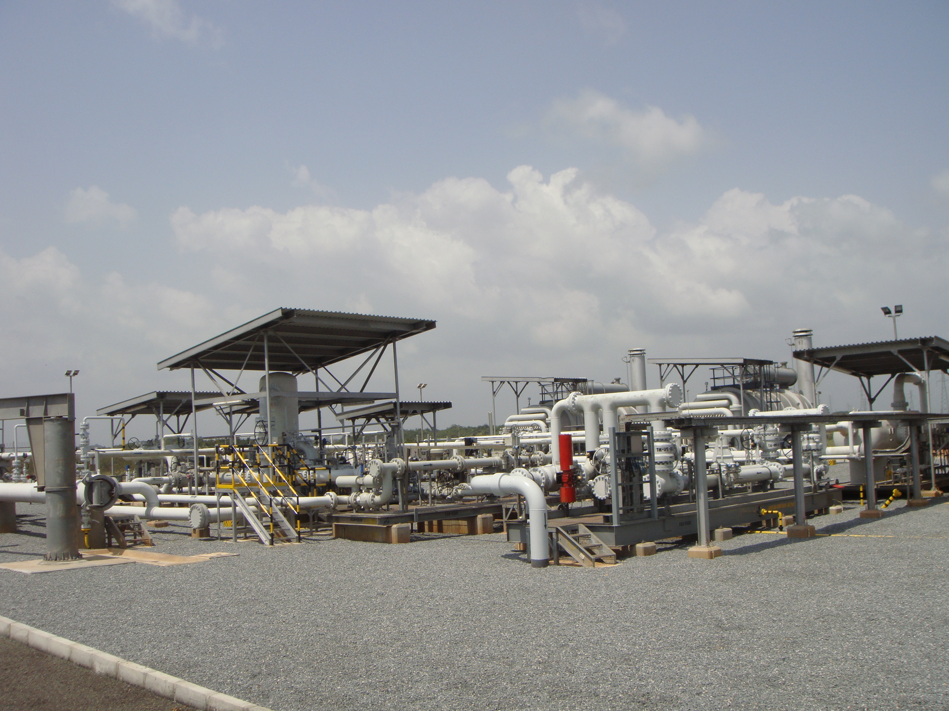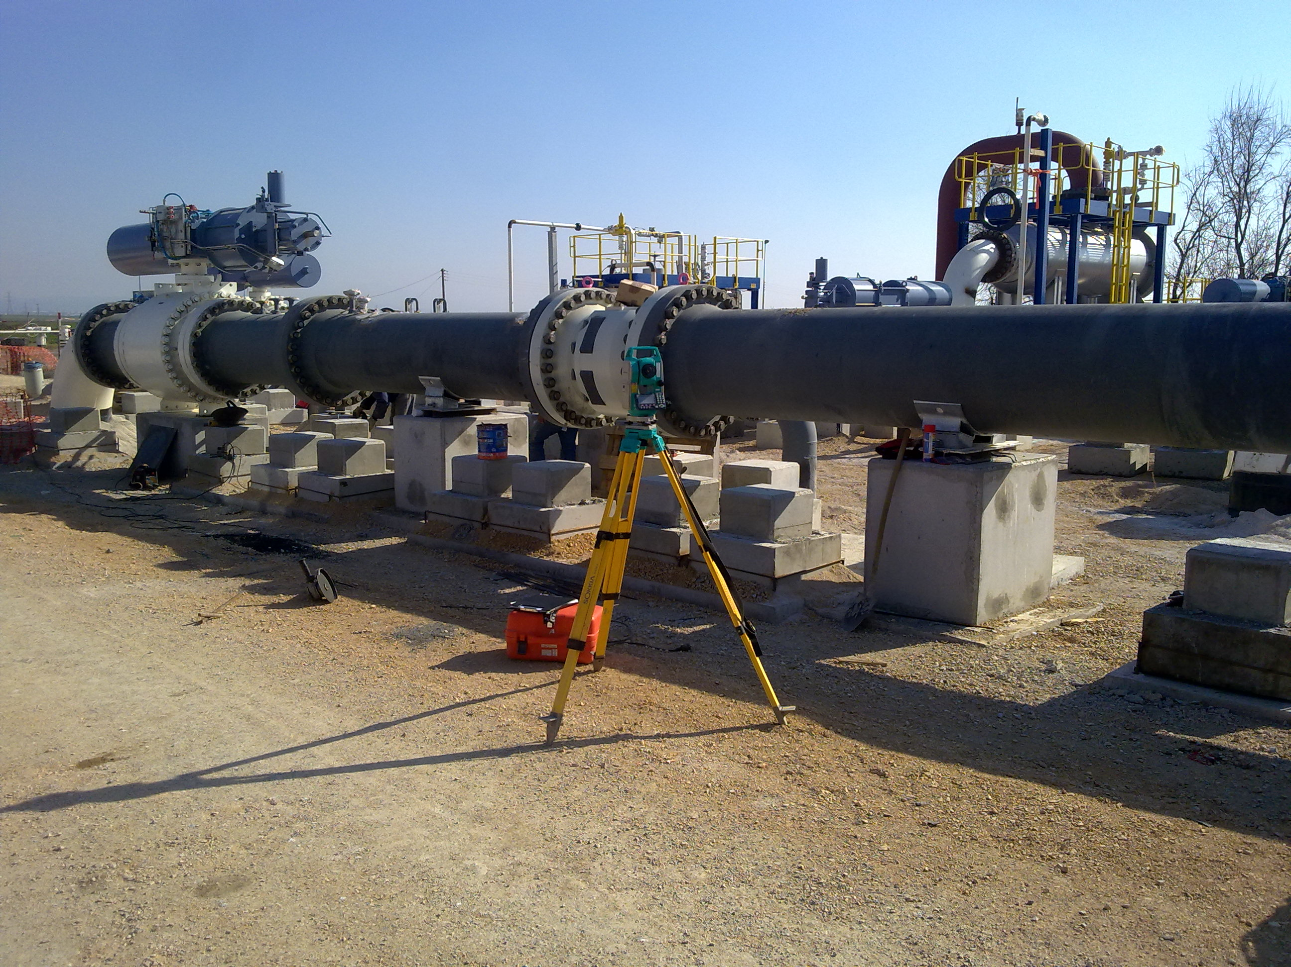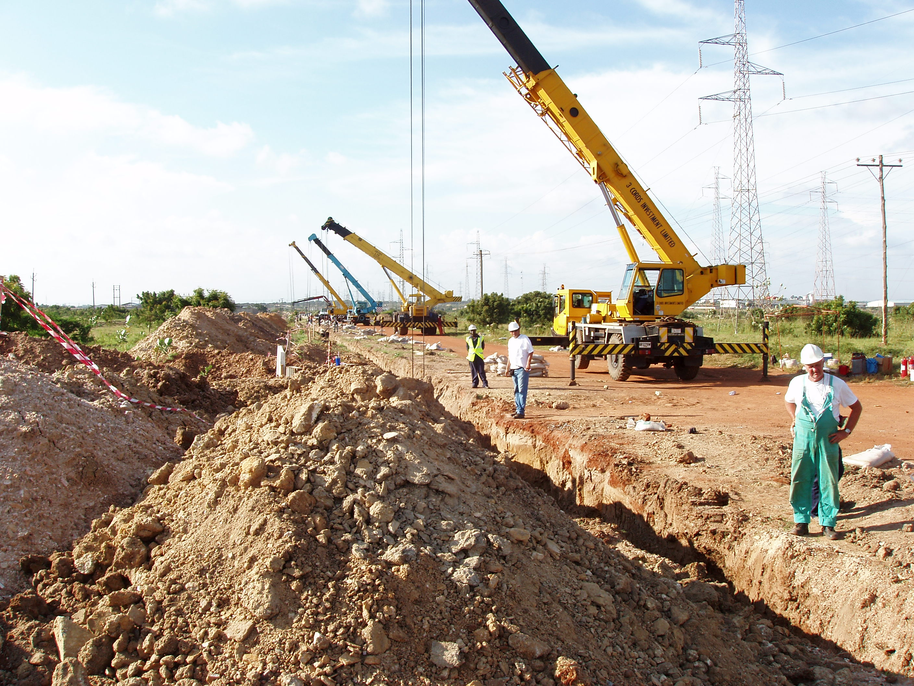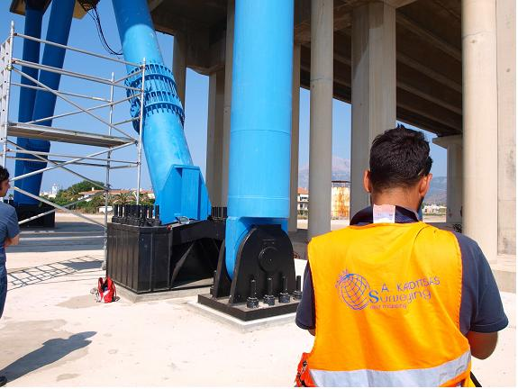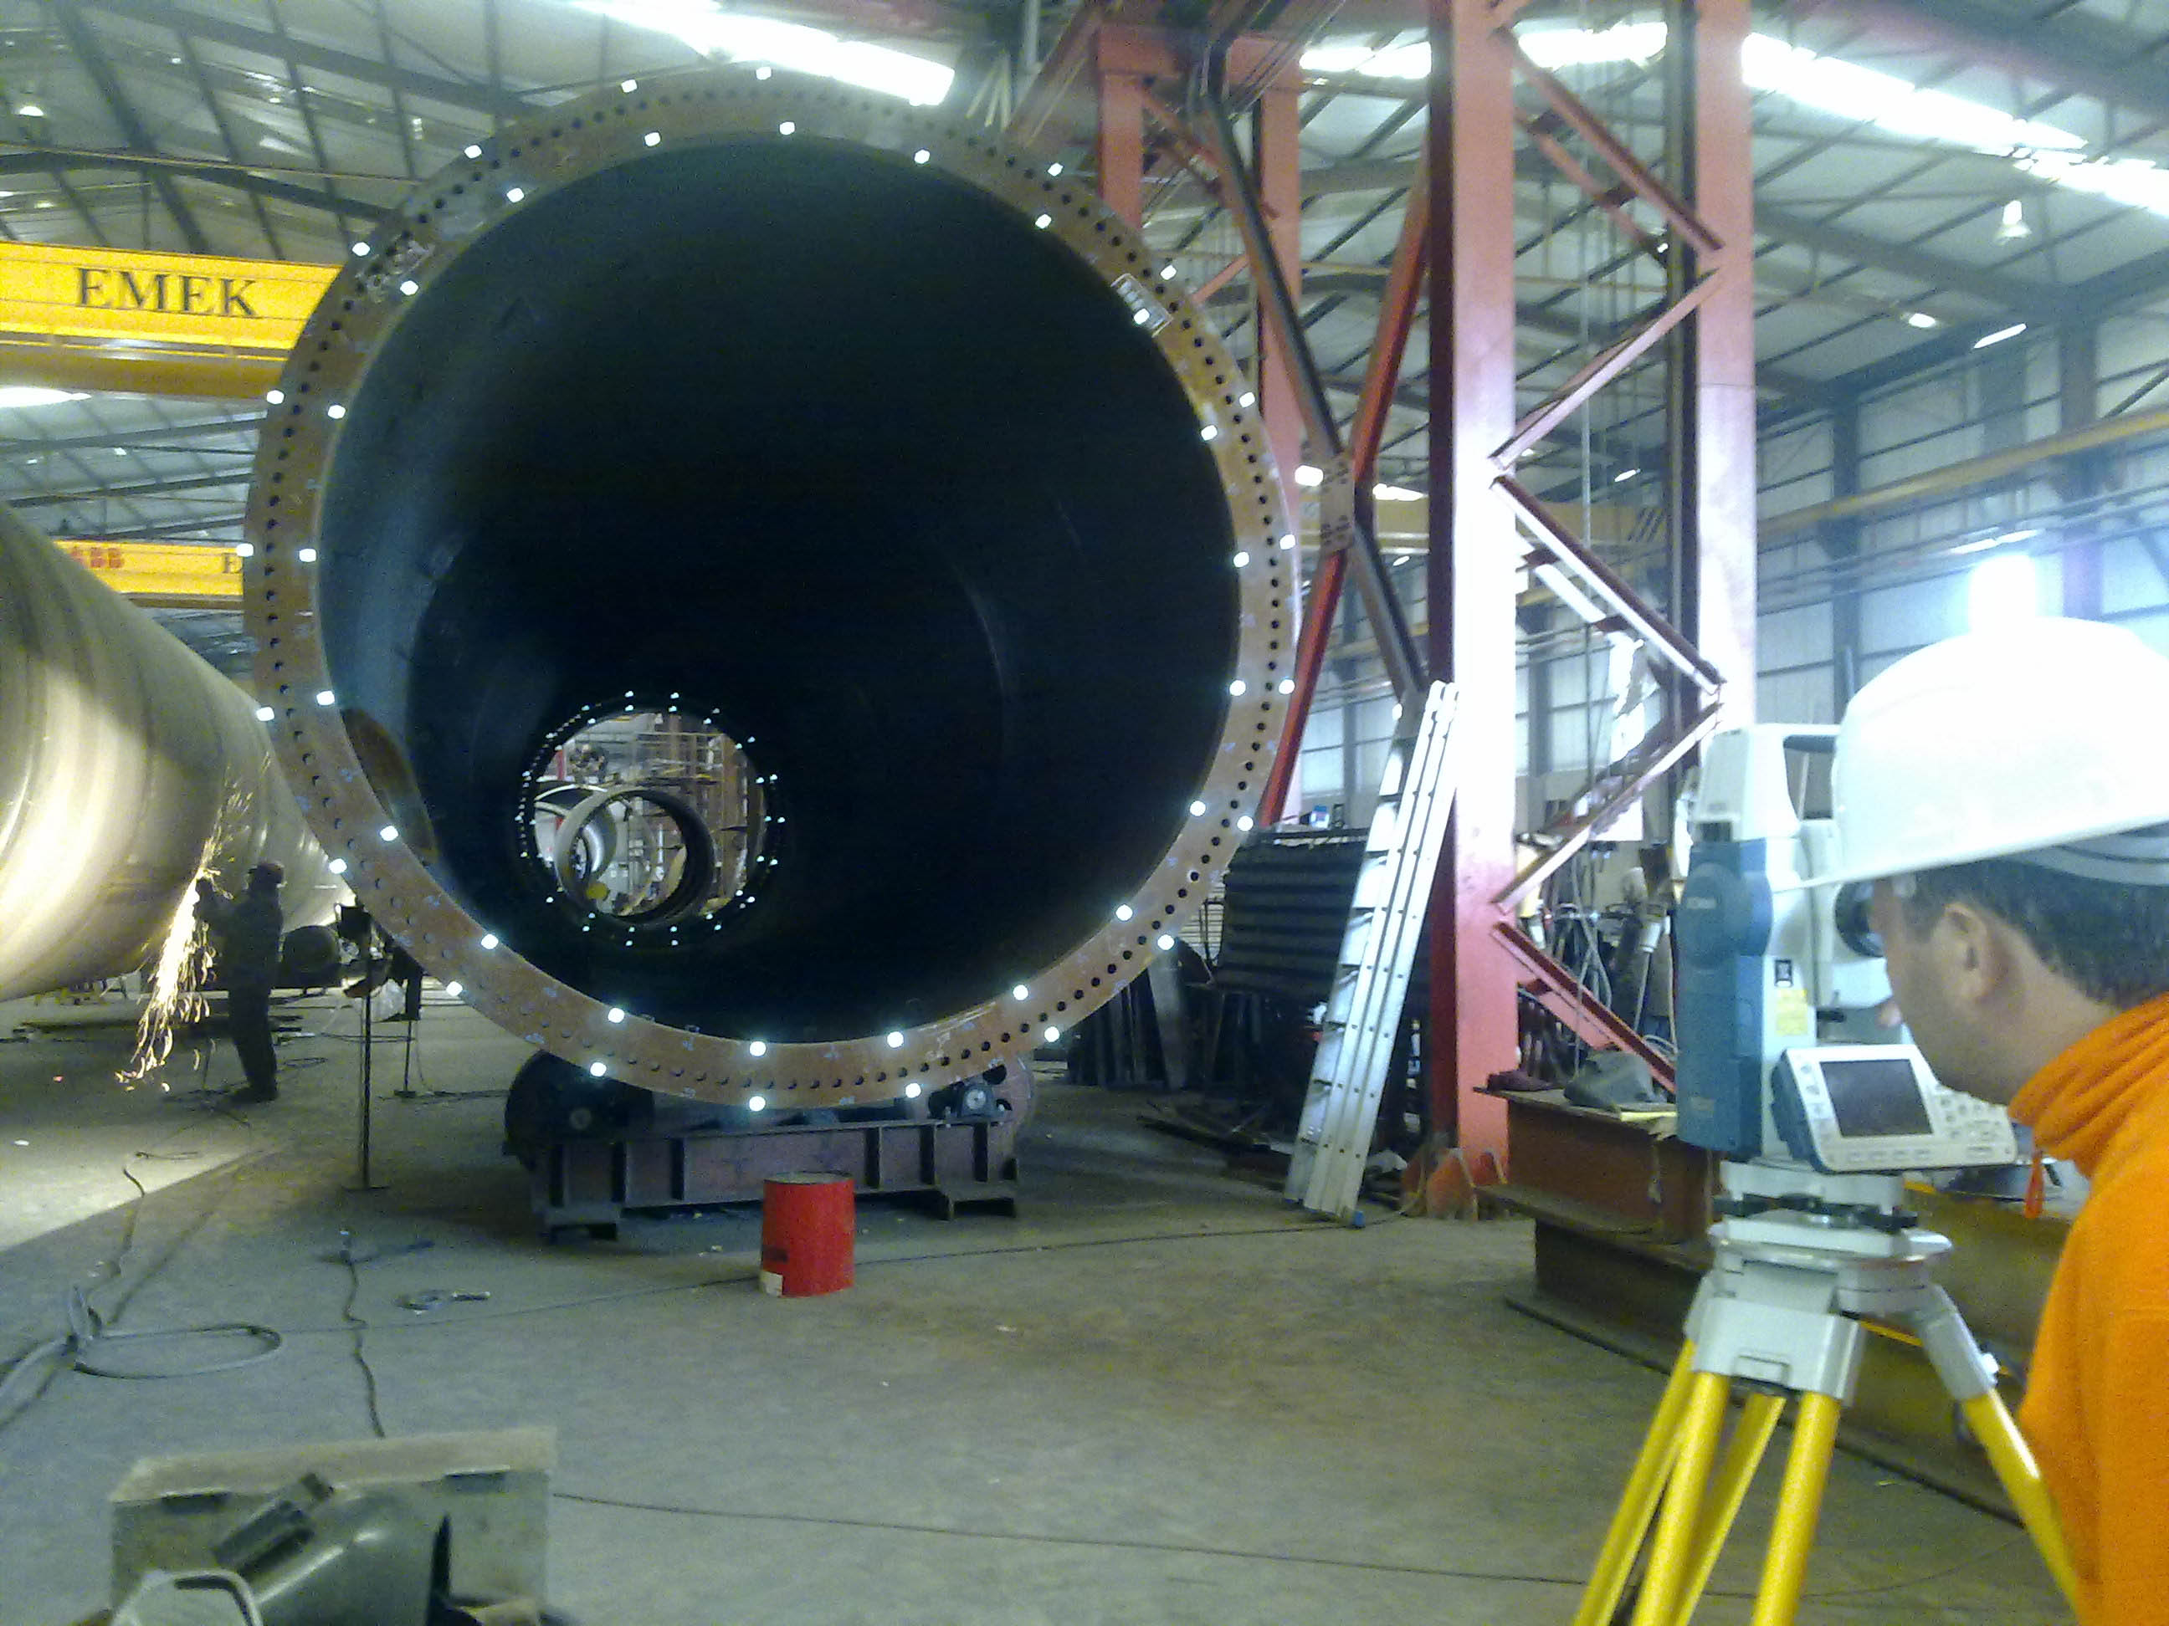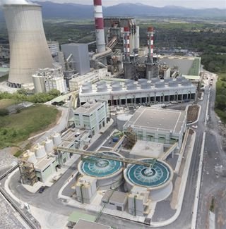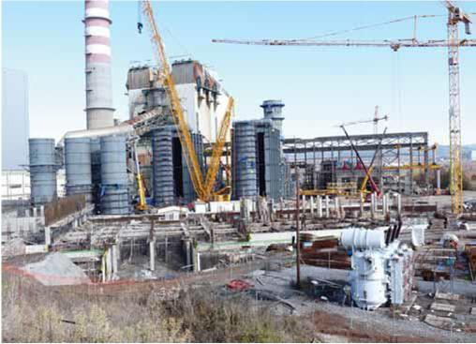

Terna S.A. – Unit V, P.P.C. S.A. Construction of new natural gas unit at Unit V of P.P.C. S.A., Megalopolis, Arkadia

Power Alstom Italia S.p.A . Unit III, P.P.C. S.A. Construction of new Wet Flue – Gas Desulphurization (WFGD) Unit at Unit III of P.P.C. S.A., Megalopolis, Arkadia.

Metka S.A. – Unit V, P.P.C. S.A Construction of Unit V of P.P.C. S.A., Aliveri, Evoia

Intrakat S.A. – 5 New Silos at Halyps Cement Industry

Construction of 5 new silos in the area of Halyps Cement Industry, Aspropyrgos, Attica

Emek S.A. – Tanks and Silos

Construction of new industrial buildings, tanks and silos, Varitimi, Milos Island

Emek S.A. – Halivourgiki S.A. facilities

Construction and extension of RM2 Unit and Spooler Unit at Halivourgiki S.A. facilities, Elefsina, Attica

Emek S.A. – Wind Turbine Towers Dimensional analysis verification survey on constructed geometry, Aspropyrgos, Attica

Emek S.A. – Rio – Antirio Bridge

Replacement of Rio – Antirio Bridge’s special parts, Corinthian Gulf

Emek S.A. – Tsakona Bridge

Construction of Tsakona Bridge, Arkadia

Emek S.A. – Gas Compression Station

Erection of gas compression station, New Messimvria, Thessaloniki

Metro S.A. – Trafigura - Tank Farm

Erection of Trafigura Tank Farm. Procurement and installation of 18’’ pipeline Thema, Ghana.

Metro S.A., West Africa Gas Pipeline Company –Natural Gas Station Erection of high pressure natural gas metering and regulating station.

4

Sidma S.A. – New Factory, Inofyta Construction of Sidma S.A. new factory production line. Inofyta, Viotia

Sidma S – New Factory, Aspropyrgos

Construction of SidmaA. new factory at Aspropyrgos, Attica

Emek S. Metal Construction Topographic support of metal construction at cement Industry of Titan S. A., Kamari, Viotia

Emek S.A – Bridge Crane

Alignment control of bridge crane rails at Corinth Pipeworks S. A. , Thisvi, Viotia

J/V Terna S.A. , Salini Impregilo S.p.A – SNFCC

Preconstruction and erection of canopy through laser scanning technique, Kallithea, Attica.

DS Steel S.A – Steel Work

Eastern structural steel work for the Doha 2006 Asian Games Ceremonies, Doha, Qatar.

Metro S.A., West Africa Gas Pipeline Company – Natural Gas Station Erection of high pressure natural gas metering and regulating station for the feeding of V.R.A at Takoradi, Ghana.

www.aksm.gr

INDUSTRIAL SURVEYING

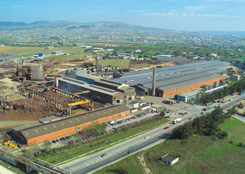

Fulgor S.A. – New Production Cable Line

Construction of facilities and new buildings for the creation of new production cable line, Korinthos

Emek S.A. – Mine Tunnels

Mine tunnels survey through point to cloud collection and verification surveys on existing equipment. Olympiada, Chalkidiki

Emek S.A. – Elefsina Shipyards

Topographic support for reconstruction of bridge crane at shipyards, Elefsina, Attica

Metron S.A. – Elefsina Refinery

Flare at Elefsina Refinery of Hellenig Petroleum, Attica

Emek S.A. – Skaramagas Shipyards

Construction and extension of industrial buildings. Topographic support for construction of new bridge crane rails, Skaramagas, Attica

Emek S.A. – Factory Area

Extension of facilities and new buildings of Emek S.A. factory, Aspropyrgos, Attica

Lubricants Cyclon S.A. – Factory Area

Topographic survey through point cloud collection Aspropyrgos, Attica

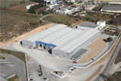

3

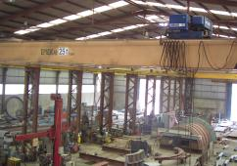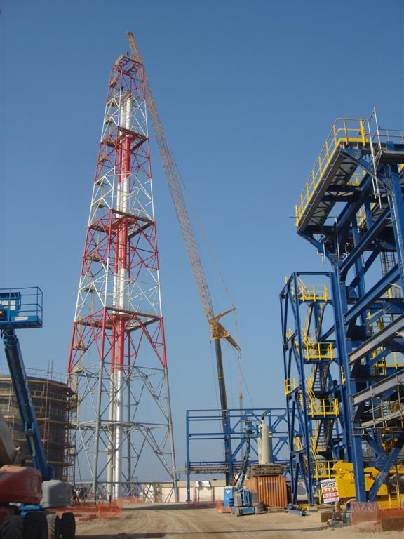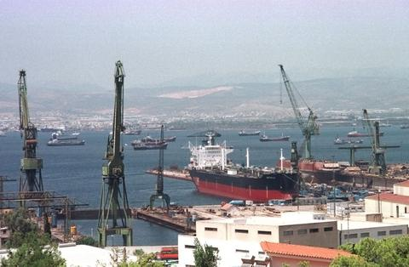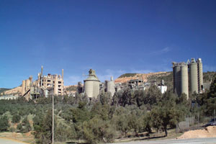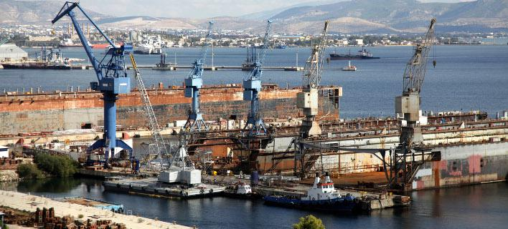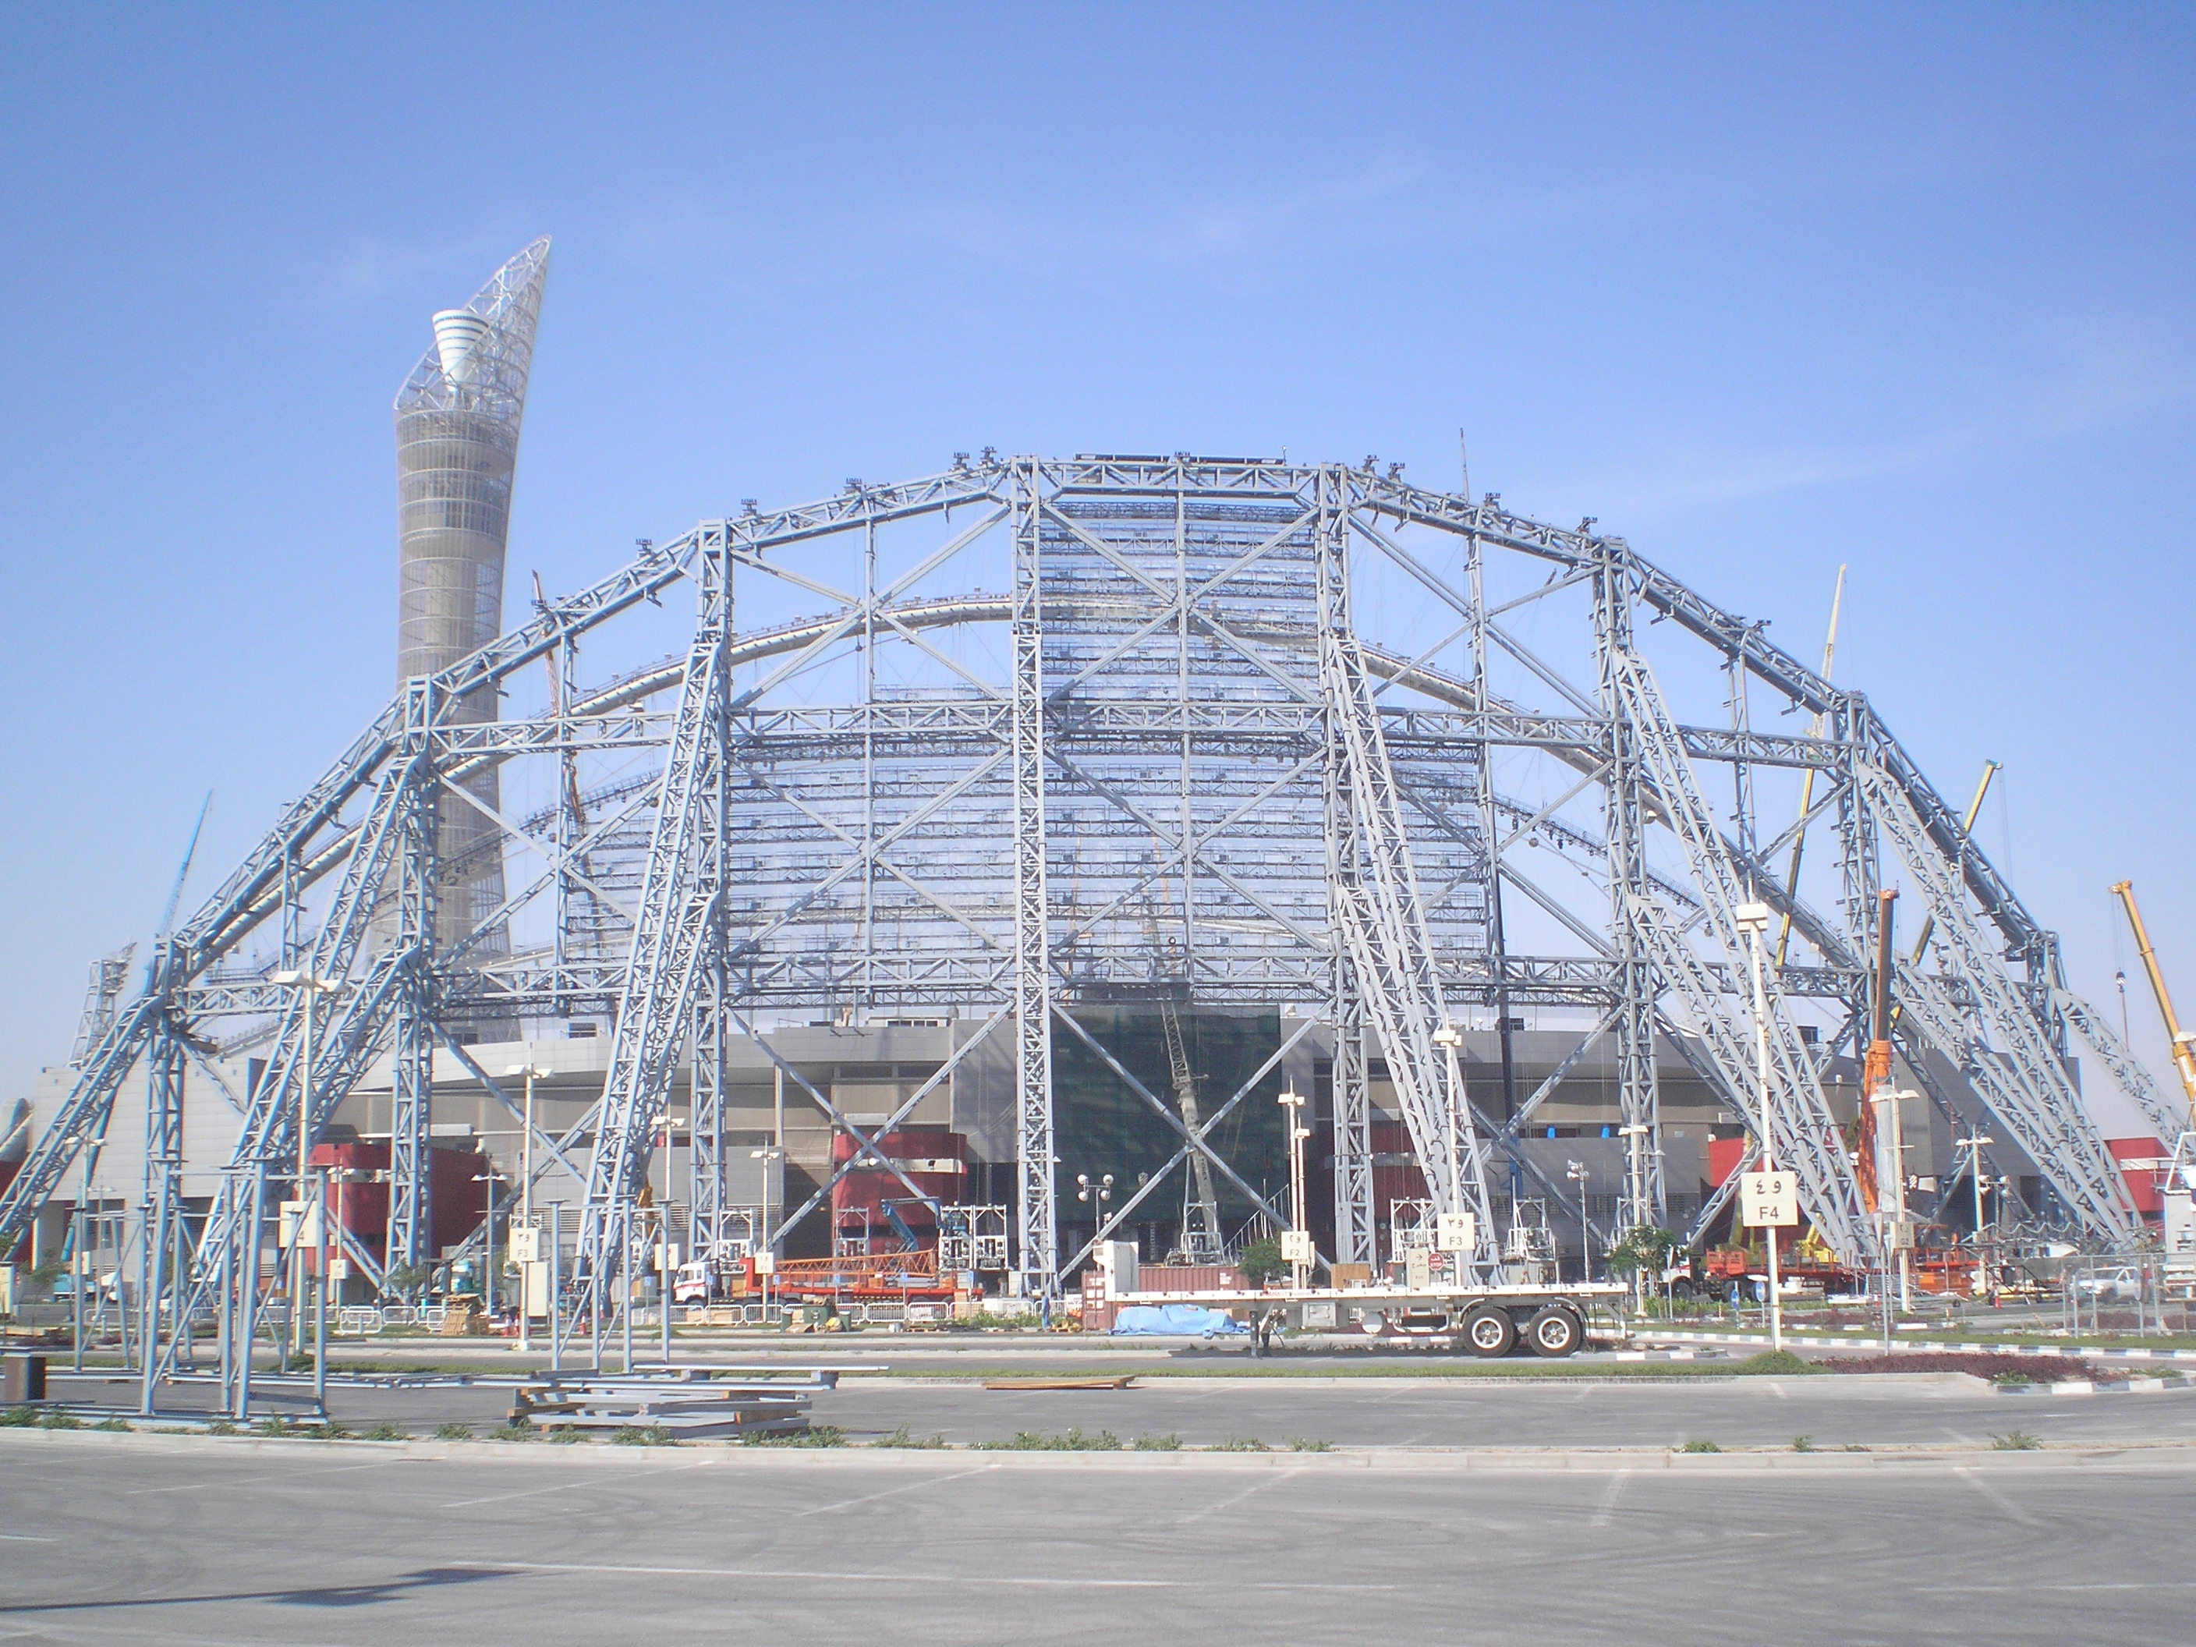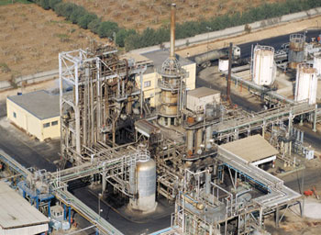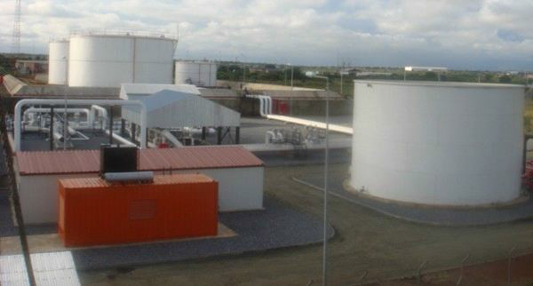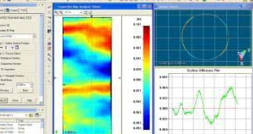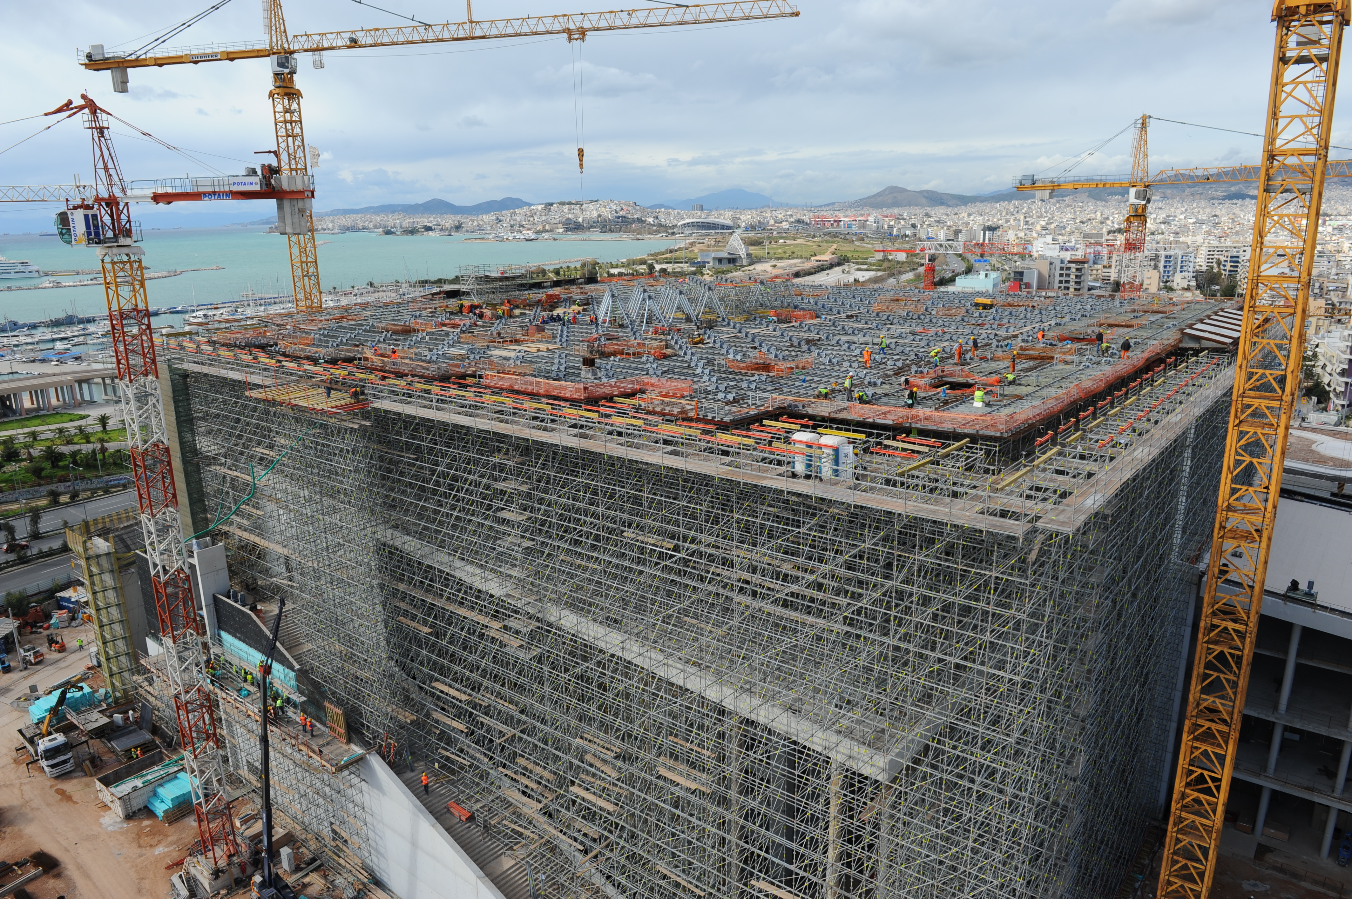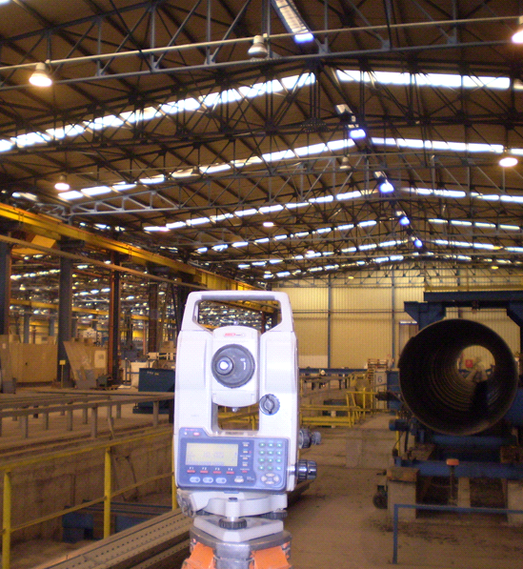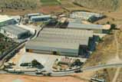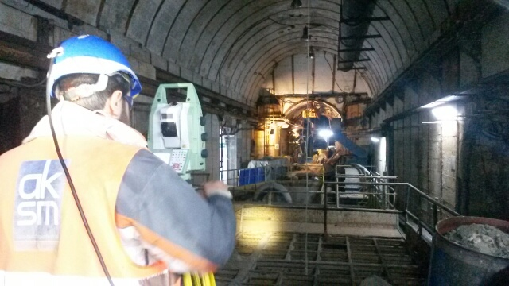

5

* Meltemi Kastri. 26 MW Wind Park Surveying , land registry and road planning for 18 km at Pilouras mountain in Magnisia, Greece.